Use of Buoy data in the

Bureau of Meteorology's Meteorological and Oceanographic Systems

Graham Warren
Bureau of Meteorology, Melbourne, Australia

Abstract

The National Meteorological and Oceanographic Centre (NMOC) in Melbourne is the central real-time operational hub for Australia's national weather service. The centre fulfils this role by:
  - maintaining a nationwide weather watch
  - providing centralised guidance products to the Regional Forecasting Centres
  - issuing a range of analysis and prediction products
  - supporting the operational communications and computing infrastructure.

For many years NMOC has operated a number of manual and numerical schemes to analyse and predict the weather, especially in the southern hemisphere. Buoy data are a key component of the observational database over the vast ocean regions where the pressure measurements are particularly important.

More recently, oceanographic systems are making a larger contribution to the centre’s output. Sea surface temperature reports from buoys, along with other in situ data are used to correct any broad scale bias in satellite retrievals, which provide the spatial coverage needed for the global SST analysis. Data from the tropical moored buoy arrays are used for products such as the upper ocean thermal analysis used for climate monitoring activities.

Introduction

The National Meteorological and Oceanographic Centre (NMOC) of the Australian Bureau of Meteorology, located in the Bureau’s head office in Melbourne fulfils an around the clock role of providing centralised analysis and prediction products of both meteorological and oceanographic fields to the Regional Forecast Centres located in each of the Australian states.

The Centre also fulfils an international role in both disciplines, namely
- A World Meteorological Centre (WMC) and Regional Specialised Meteorological Centre (RSMC) of the World Meteorological Organisation (WMO) World Weather Watch.
- A National Data Processing Centre of the International Oceanographic Commission (IOC)/WMO Joint Commission for Oceanography and Marine Meteorology.

This paper describes the use and requirements of buoy data for both meteorological and oceanographic analyses that are produced routinely.

Meteorological Analysis

As part of the role as a WMC an historical record of the synoptic patterns over the southern hemisphere is produced twice a day. The Mean Sea Level (MSL) analyses are also used as the basis for pseudo-observations used by Numerical Weather Prediction (NWP) systems. Traditionally, the MSL analyses have been produced manually where the ability of the analyst to recognise features on satellite imagery are blended with available observations. The analyses are now produced on-screen using a package developed by the UK Met Office. Again, analysts can adjust the field, produced by merging the influence of observations with a NWP field, based on their experience by inserting pseudo-observations.

The analyses produced by the NWP system employ accurate short-term forecasts as first guess fields which are then blended statistically with observations.

Both manual and numerical techniques for analysis depend on good spatial coverage of observations available in a timely fashion. The percentage of buoy observations received as a function of their arrival time in the NMOC database is shown in Fig. 1. This shows that 90% of buoy observations are available within 6 hours which is the cut-off for the southern hemisphere analysis and the Global NWP run. Most of the observations after this time are most likely duplicates which overwrite the original message.

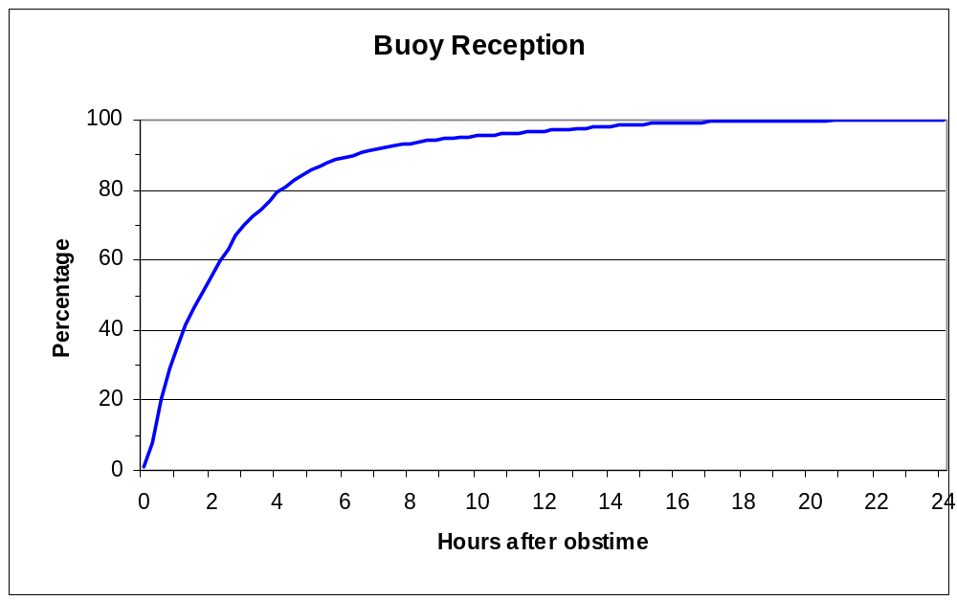Fig. 1. Percentage of buoy reports received at given hour after observation time.

As a by-product of the numerical analysis scheme used for NWP described in Seaman et al. (1995) it is possible to calculate the impact of removing individual observations from the system (Seaman, 1994). For the MSL analysis in the southern hemisphere the highest contribution is obtained, not unexpectedly, from island stations and buoys. The top 10 buoys impacting on the analysis averaged over July-September 2001 are listed in Table 1 below.

Buoy ID | Lat | Long | Rms | max
17647 | 59.3S | 56.5E | 1.7 | 4.7
74531 | 55.1S | 117.5E | 1.7 | 4.8
71554 | 71.8S | 145.8W | 1.7 | 5.2
74534 | 54.9S | 94.3E | 1.3 | 4.0
16536 | 57.6S | 133.5E | 1.3 | 3.5
71513 | 68.7S | 74.9W | 1.2 | 5.2
73509 | 59.4S | 78.2W | 1.2 | 5.2
73502 | 62.9S | 93.1E | 1.0 | 3.5
33576 | 45.8S | 18.2E | 0.9 | 3.1
54858 | 46.4S | 160.7W | 0.9 | 2.7
Table 1. Buoys having the greatest impact on MSL analysis in the southern hemisphere. Rms is average rms impact over the 3 months, max is maximum impact.

Oceanographic Analysis

A global sea surface temperature (SST) analysis based on a blend of in situ and remotely sensed data has been running in NMOC since 1993. The output is used to define the boundary temperature for NWP and anomalies from climatology used for climate monitoring. The analysis scheme is based on the ocean thermal analysis scheme of Smith (1995) and statistically weights different observation types with a first guess field which is the best estimate of the SST without observations. In our case this is a combination of the previous analysis and climatology. In the analysis the greatest statistical weight is always given to buoy data.

Because of the sparse coverage of in situ data (Fig. 2), especially in the southern hemisphere, it is necessary to use remotely sensed data to get full global coverage. The satellite data is calibrated against buoy reports but, due to the presence of aerosols in the atmosphere such as volcanic ash, it may be biased. To account for any bias separate in situ and satellite analyses at low resolution are performed using broad correlation scales at which it is assumed that the in situ data provides sufficient coverage. The difference between these coarse analyses is used to adjust the satellite data for the final higher resolution analysis.

Output statistics from the analysis scheme can be used to check the accuracy of input data over a period of time and also as a means of detecting suspect data which can then be more thoroughly investigated.

In other oceanographic systems extensive use is made of other data types such as wave buoy data which is used for verification of wave model forecasts, TAO array buoy data which is used for el Nino monitoring and ocean modelling and ARGO float data used for subsurface temperature analysis and ocean modelling. These are all becoming increasingly important for maintaining the operational products at current performance levels.

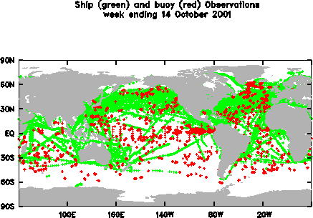
Fig. 2 Global coverage of ship (green) and buoy (red) data for the week ending October 14 2001.

Conclusions

For the operation of the historical record and to fulfil international obligations, the maintenance of current levels of ocean observation coverage is essential. Pressure readings on drifting buoys have been shown to have a positive impact on both manual and numerical analyses in the southern hemisphere. Sea surface temperature measurements from buoys and other in situ measurements are extremely useful for forecasting and calibration of remotely sensed data.

References

Seaman, R.S. 1994. Monitoring a data assimilation system for the impact of observations. Aust. Met. Mag., 43,41-48.

Seaman, R.S., Bourke, W., Steinle, P., Hart, T., Embery, G., Naughton, M. and Rikus, L. 1995. Evolution of the Bureau of Meteorology’s global assimilation and prediction system. Part 1: analysis and assimilation. Aust. Met. Mag., 44, 1-18.

Smith, N.R. 1995: The BMRC ocean thermal analysis system. Aust. Met. Mag., 44, 93-110.

